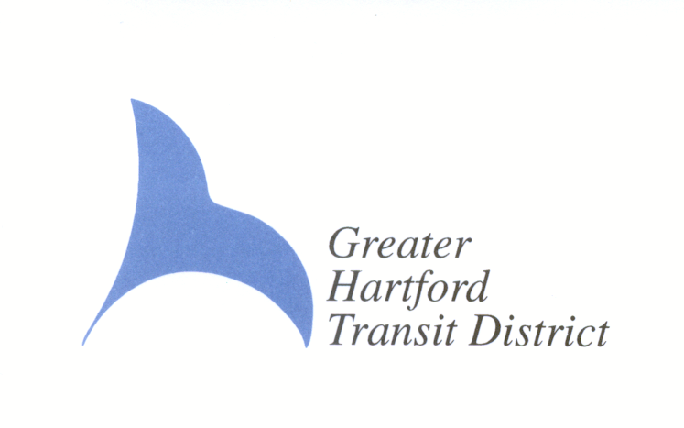
NOTICE - **VENUE CHANGE**

GREATER HARTFORD TRANSIT DISTRICT
ADA PARTICIPATION GROUP FORUM

The Greater Hartford Transit District will hold a virtual public forum on Wednesday, January 12, 2022 from 5:00 p.m.-6:00 p.m. Please join from your computer, tablet or smartphone.

https://us06web.zoom.us/j/82570689879?pwd=Vit1dkpwL3publVLVjNCVGNRNXhlUT09

Meeting ID: 825 7068 9879
Passcode: 504484

You can also dial in using your phone: 1 929 205 6099
FOR FURTHER INFORMATION
CALL (860) 724-5340 AND SELECT 1

The forum will include:

- General ADA Update provided by staff.
- Public participation related to the ADA Paratransit service.

UP TO 48-HOURS IN ADVANCE OF THE FORUM, WRITTEN PARTICIPATION RELATED TO THE ADA PARATRANSIT SERVICE MAY BE:
- MAILED TO THE GHTD, ATTN: P. WILLIAMS, ONE UNION PLACE, HARTFORD, CT 06103
OR
- EMAILED TO: pwilliams@ghtd.org

If information is needed in another language, contact 860-247-5329 x3011

French
Si des renseignements sont nécessaires dans une autre langue, composez le 860-247-5329, poste 3011.
Serbo Croatian
Ako su vam potrebne informacije na drugom jeziku, nazovite 860-247-5329 x3011
Portuguese
Se precisar de informações em outro idioma, ligue para 860-247-5329, ramal 3011.
Italian
Se avete bisogno di informazioni in un’altra lingua, telefonate al numero 860-247-5329 int. 3011.
Polish
Jeżeli istnieje zapotrzebowanie na te informacje w innym języku, prosimy o kontakt na numer telefonu 860-247-5329 wewn. 3011.
Russian
Если Вам необходима информция на другом языке, пожалуйста, обращайтесь по номеру телефона 860-247-5329, доб. 3011.
Spanish
Si necesita información en otro idioma, llame al 860-247-5329, extensión 3011.
Chinese
如需其他语言的信息，请致电 860-247-5329 x3011
Vietnamese
Nếu cần thông tin bằng ngôn ngữ khác, hãy gọi 860-247-5329 x3011
Korean
다른 언어로 기재된 정보가 필요하신 경우, 860-247-5329 x3011로 연락해 주시기 바랍니다.
Hindi
यदि जानकारी अन्य भाषा में चाहिये, 860-247-5329 x3011 संपर्क करेंج
Arabic
في حالة الاحتياج للمعلومات بلغة أخرى، يرجى الاتصال على رقم 5329-247-860، داخلي 3011
Gujarati
જો બીજી ભાષામાં માહિતી લેવાની જરૂર હોય, તો 860-247-5329 x3011 પર સંપર્ક કરો.

